Extra Whipped Chocolate Chip Cookies

3/4 cup soften butter
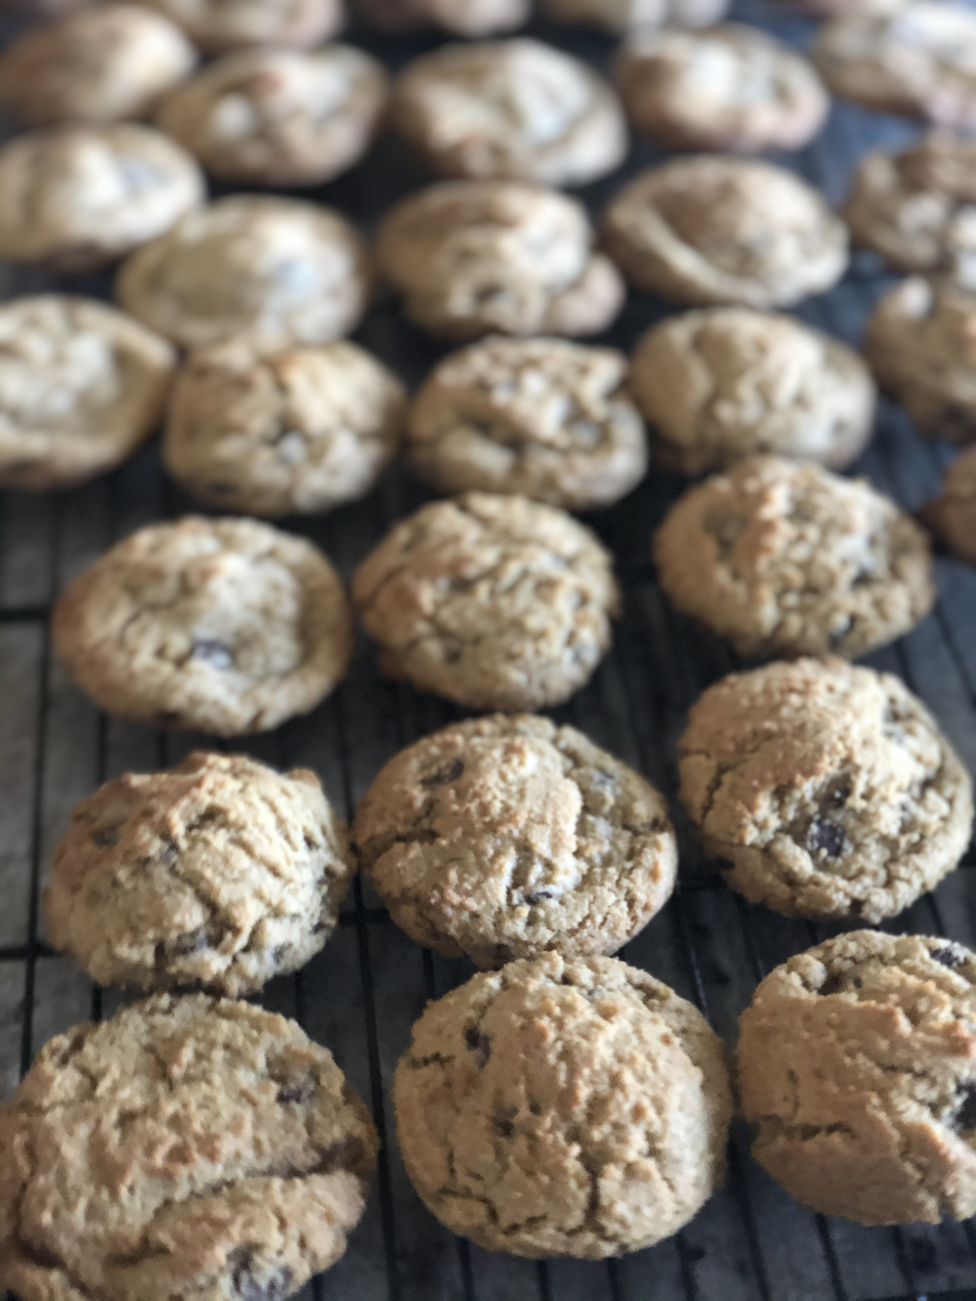

1 cup brown sugar
1/4 cup granulated sugar
1egg
1tsp vanilla
2 Cups Flour
1 tsp baking soda
1/2 tsp salt
1/2-3/4 cup chocolate chips
Whip the butter and both sugars in a stand mixer for 5- 8 minutes. Add the egg and vanilla and beat for another 2-3 minutes. In a seperate bowl mix the flour, baking soda and salt. Mix the flour mixture into the butter mixture until almost completed combined then add the chocolate chips. Scoop onto a parchment lined cookie sheet and refrigerate for about an hour. Bake for 8-10 minutes in a 375 preheated oven.

