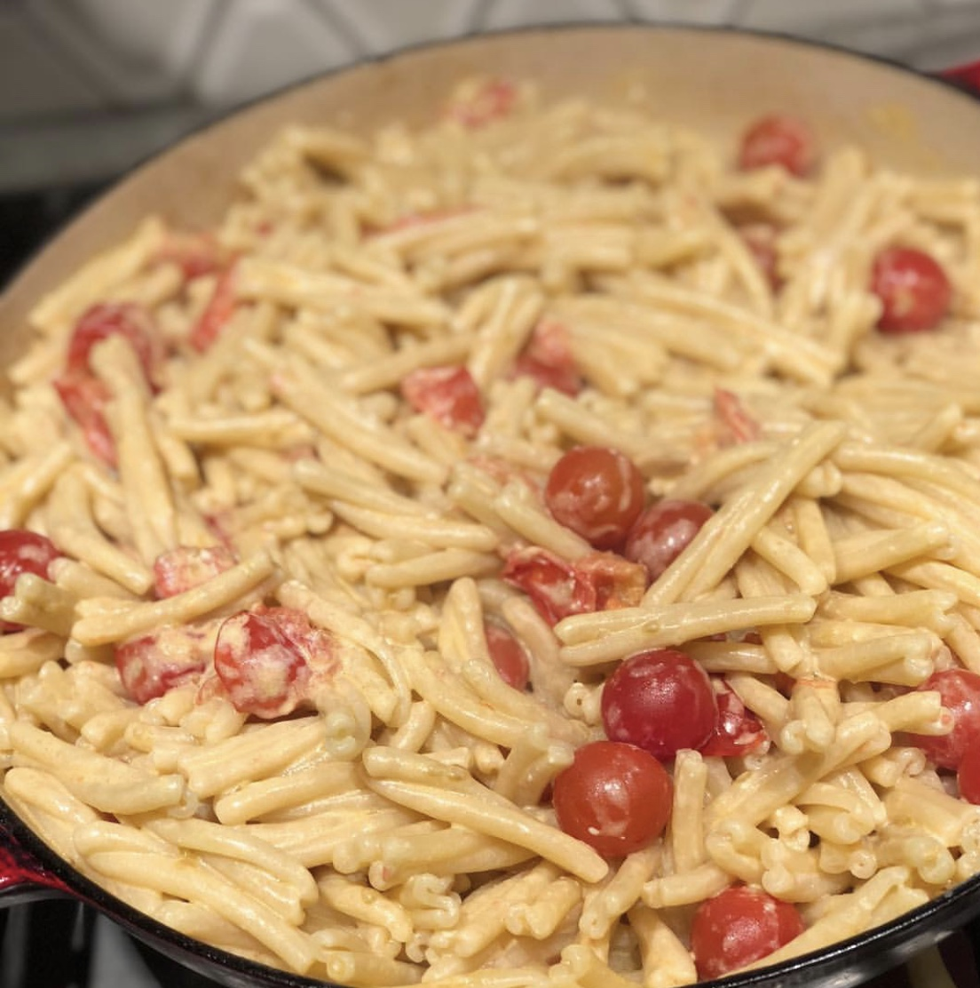 Creamy Cherry Tomato & Vodka Sauce

Sauce  1 Package of short pasta  3 Tbsp olive oil  2 tsp anchovy paste  1 garlic clove, crushes  20 cherry tomatoes  1/4 cup vodka  1/2 cup mascarpone cheese  parmigiano to finish | ​  ​Bring a pot of water to boil, generously salt it. Toss in a package of pasta, stir and return the lid to bring it back to a boil. once it is boiling again, stir occasionally leaving the lid off.  In the mean time heat oil in a heavy bottom frying pan, dissolve the anchovy paste and stir in the garlic clove, cook for 30 seconds. add in the tomatoes so they cook down and some begin to burst open. add the vodka allowing it to cook for about 3 minutes. stir in the mascarpone. Once the pasta is al dente, reserve 1 cup of the pasta water before draining the pasta. Add the drained pasta to the sauce and toss. If it seems to thick, use a small amount of the reserved pasta water to thin it out. Top with parmigiano and enjoy.  ​  ​  @atavolayyc @a_tavolayyc