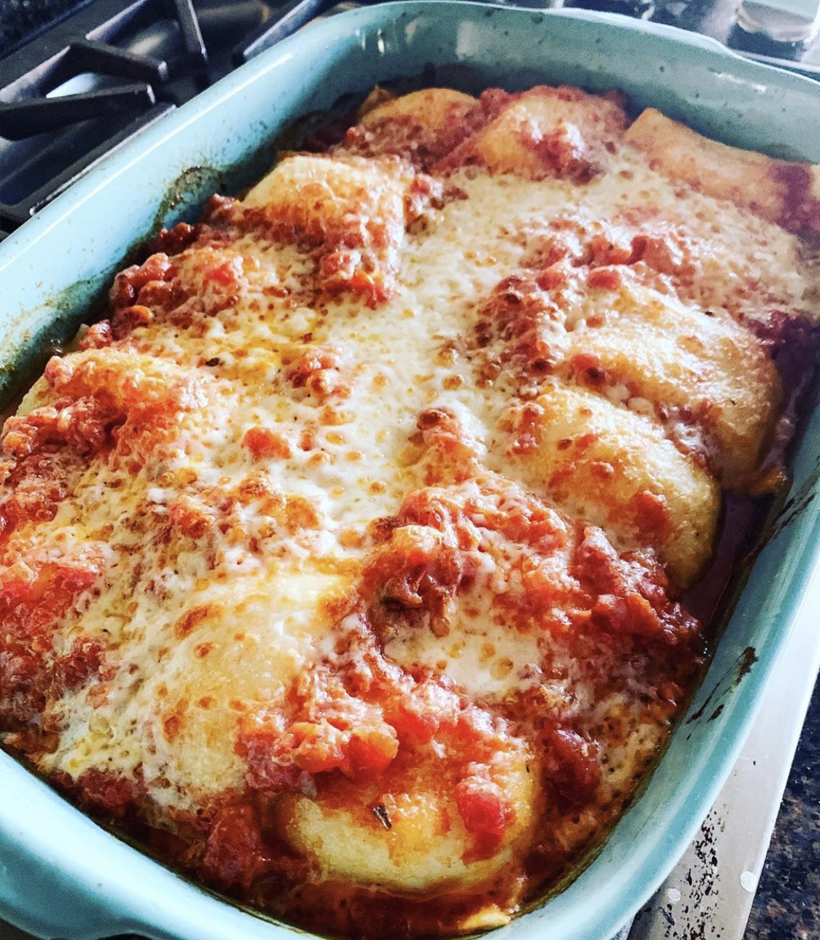 Baked Ravioli

1 Package frozen ravioli  2-3 cups prepared red sauce  1 cup shredded mozzarella  1/4 cup grated parmesan | ​  - Preheat the oven to 350. Prepare a 9 x 13 baking dish.  - Bring a large pot of water to a boil. Once the water has boiled, add a generous pinch of salt to the water then add the pasta and cook half the amount of time according to the package instructions.​  - Drain the pasta. Place a layer of ravioli at the bottom of the prepare baking dish try not to overlap. Laddle 1 cup of red sauce on top, sprinkle with 1/2 mozzarella and 1/2 parmesan. Layer ravioli one more time.  - Cover and bake for 30 minutes. Uncover and bake or broil for 5 minutes.  ​

@atavolayyc @a_tavolayyc

